Version: 0.1 (07-04-2018)

Version 0.7 final proposal (March 2019)

Version 1.0 draft (September 2020)

***The main questions are :***

**How do EOCC members handle the presence of phosphonic acid in products?**

**How do EOCC members handle the presence of Fosetyl in organic products?**

**Summary**:

Phosphonic acid (H3PO3) is considered as a pesticide residue because it is included in laboratory reporting for the fungicide fosetyl-aluminum (Fosetyl-Al). Fosetyl-Al is not a stable molecule and degrades easily into fosetyl. Fosetyl degrades easily into phosphonic acid and it’s salts. From a laboratory perspective, when looking for Fosetyl-Al or metabolites of Fosetyl-Al, it’s correct to state that detections of phosphonic acid have to be related to Fosetyl-Al.

However, in practice, the presence of phosphonic acid and its salts in plants and plant products can be explained by other reasons as well. Some of the reasons are in line with organic production where others are not. The use of Fosetyl-Al is not allowed in organic farming.

In practical situations, it is very difficult to identify the real origin(s).

**This situation is problematic for the organic sector because detections of phosphonic acid in organic products result in blocking concerned products and operators from using those products while operators and control bodies investigate the situation to identify the true origin of the phosphonic acid. Experience shows that the presence of phosphonic acid in an organic product does not necessarily result from use of the unauthorized substances like the fungicide Fosetyl-Al or chemical fertilizers.**

**Proposal for harmonization:**

1. **Actions to be taken by control bodies/authorities**:
2. ***Investigation****:* 
   1. An official investigation shall be performed for every detection of Fosetyl-Al, even for the mere presence of phosphonic acid without detection of Fosetyl-Al, and independently from its concentration.
   2. The Official investigation should use the different tools included in Article 14 and Article 137(3) of REGULATION (EU) 2017/625.
   3. Before the investigation takes place, the CA/CB will assess the likelihood of non-compliance to choose the tools to be used.
   4. The official investigation shall take into account the evaluation of the results and the context of sampling and will aim to verify that only authorized substances have been used and adequate and proportionate precaucionary measures were taken at the level of the operator where the sample was taken or which was notifed.
3. ***Certification decision after the investigating****:*
4. If the phosphonic acid is due to the use of unauthorized substances during organic management of the crop, application of article 30 of Regulation 834/2007 and the applicable catalogue of measures.
5. If the phosphonic acid is due to use of authorized substances and the applicable MRL value is not exceeded, the batch can be used and sold as organic.
6. If the phosphonic acid is due to the use of substances not allowed for use under organic management, but the use has taken place prior to organic managent, the batch can be used and sold as organic.
7. In case the source of the phosphonic acid has not been identified, the product has to be released as organic. The operator is considered as higher risk operator. Additional audits (and sampling/analysis of other batches) will have to be performed.
8. **Actions to be taken by operators receiving analytical results indicating the presence of fosetyl or phosphonic acid without presence of fosetyl**,
   1. The operator will follow what is described on article 91.1 of Regulation (EC) 889/2009 informing the CA/CB in case that the doubt of non compliance can not be discared.
9. **Recent Studies on phosphonic acid origins**

Looking at results of recent scientific research, it can be summarized that the presence of **phosphonic acid (H3PO3) and its salts** in plant products can be explained by three types of origins:

1. The **unavoidable presence** in the plant and/or the soil due to use of plant strengtheners, foliar fertilisers (possibly containg “P” when used before 2013 in DE), other kind of fertilizer/soil amendments or plant protection products based on Cu but also containing “P”, even two or three years before sampling , due to spray drift and/or growth under stressful conditions e.g. drought, flooding etc.
2. The **use of prohibited substances** on the plant or soil due to the use of Fosetyl-Al application, the use of chemical fertilisers containing phosphorous, the use of chemical fertilisers containing phosphorous mixed with Fosetyl-Al, the use of chelating agents in the preparation of soil amendments and/or irrigation water containing “P”.
3. The **use of authorized substances** on organic land. REGULATION (EU) 2019/1009 OF THE EUROPEAN PARLIAMENT AND OF THE COUNCIL of 5 June 2019 entry into force on 16 of July 2022, in its Annex I. Part II.6 states that "Phosphonates shall not be intentionally added to any EU fertilising product. Unintentional presence of phosphonates shall not exceed 0,5 % by mass” but still some inputs used in organic farming could have different amount of phosphonic acid because its nature as some researches have released regarding purins or manure as soil amendments, algae or waste products from grapes/wine/fortified drinks preparation. Besides this, EOCC has undertaken an internal research through their members asking for analyses of inputs (positive and negative result) affecting 60 samples taken by CA/CBs and 20 samples taken by operators with these conclusions:

- Variable quantities of phosphonic acid seem to be present not only in fertilizers (annex I of EC 889/2008), but also in some pesticides (annex II of EC 889/2008) allowed in the regulation.

- Products or by-products of animal origin seem to not contain phosphonic acid.

- Some products and by-products of plant origin showed variable quantities of phosphonic acid. In particular, by-products from the winemaking and distillery industry (4/4 of the ones tested) seem to show relevant concentrations of this substance in line with French experience that shows that fosetyl could also be formed as an artefact during production or storage of wine.

- 3 out of 4 phytosanitary products derived from “Micro-organisms or substances produced by or derived from micro-organisms” showed variable quantities of phosphonic acid/fosetyl.

- There is a relevant number of ready-to-use products (mixed formulation) on the market which show variable quantities of phosphonic acid/fosetyl.

In investigations with analysed inputs that have phosphonic acid contamination, CA/CBs should assess what is the risk that the source of the finding in the final product of phosphonic acid would be related with the use of the inputs. CA/CBs should take into account at least:

o The way the input works and solubility (spray to the vegetal tissues, add to soil, etc)

o Dose used

o Times used per crop

In this diagram are described 3 possible sources of finding phosphonic acid in final products with some examples:

* Red: Contamination by use of non authorized substances
* Blue: Contamination by drift of former authorized inputs currently non authorized
* Green: Use of authorized inputs

|  |
| --- |
|  |

A more detailed explanation of these mechanisms is given in the background information (see further)

1. **The methodology of the investigation:** start by collecting evidence to support each of the hypothesis mentioned hereunder. If there is no evidence supporting the first hypothesis, start with the second. (Worst case scenario first)

Hypothesis 1: not authorized substances have been used

To confirm or deny this hypothesis, consider at least the follow elements:

Regarding Fosetyl-Al application:

* Is the use of Fosetyl-Al authorized on this crop in non organic farming in the country where the crop is grown?
* Is the use of Fosetyl-Al authorized on crop grown under non organic management in another production unit on the same holding?
* Is the use of Fosetyl-Al relevant in relation to the risk of fungi in the period of 1 month prior to sampling?

Regarding chemical fertilizer:

* Is the sampled crop sensitive to lack of “P” in the soil?

Regarding the use of soil amendments, “enriched” with Fosetyl-Al:

* Is there any documentation left of soil amendments used?
* Is there any product remaining for sampling?

Regarding the use of soil amendments containing “P” in the chelating agents?

* Is there any documentation left of soil amendments used?
* Is there any product remaining for sampling?

Regarding the use of irrigation water “enriched” with soluble forms of “P”

* Is there any record keeping in relation to irrigation water quality?
* Is the irrigation system a closed system?
* Is there an organic and non organic production unit which is irrigated by using the same source?

Hypothesis 2: Authorised substances containing phosphonic acid (natural presence) have been used

Regarding the possible sources of phosphonic acid, verify whether one or more of the following substances have been used

as soil amendment:

* Algae
* Purins
* Manure
* Waste products of the wine industry

plant strengtener or foliar fertilizer containing “P”.

micro-organisms

other inputs containing aminoacids

Hypothesis 3: Spray drift from neighbouring non organic productions:

Regarding Fosetyl-Al application by neighbouring farmers:

* Is the use of Fosetyl-Al authorized on those crops in non organic farming in the country where the crop is grown?
* Is the use of Fosetyl-Al relevant in relation to the risk of fungi in the period of 1 month prior to sampling?

Regarding plant strengtheners or foliar fertilizer containg “P”: check the plant records and needs of the crops of the neigbouring farmer.

# Vocabulary

|  |  |  |  |
| --- | --- | --- | --- |
| Phosphonic acid | Phosphorous acid |  | H3PO3 |
| Phosphite salts, salts of phosphourous acid | phosphites | phosphonate | H2PO3-, HPO32- and  PO33- |
| Fosetyl | Ethyl phosphonic acid |  | CH3-CH2-PO3- |
| Fosetyl aluminum | Fosetyl-Al |  | Al(CH3-CH2-PO3)3 |
| phosphate |  |  | PO43- |

# Fosetyl-Al

It is an organic phosphate compound used as a systemic fungicide with protective activity. It is rapidly absorbed through the plant leaves or roots, with translocation both up and down inside the plant. The active substance in the plant is potassium phosphonate which is active by inhibiting spore germination and penetration into the plant, and by blocking mycelial growth and spore production of mildew (*Peronospora*) in particular. In 2014 and in Germany, plant protection products containing fosetyl as active substance are registered against certain fungi such as phytophtora and Pythium-type plant pathogens (on salads, cucumbers, tomatoes, herbs, hops strawberries and vines. Also has a useful activity against several bacterial plant pathogens. Use of Fosetyl-Al is not allowed in organic farming.

# Laboratory analysis

Laboratories are able to detect fosetyl, phosphonic acid and its salts, in a multi-residue method. Specific individual methods for the determination of fosetyl in fruit and vegetables also exist. The applied methodology is LC-MS/MS. Reporting limits (RL) may vary between laboratories. Examples of reporting limits are given in the table below:

|  |  |  |  |  |
| --- | --- | --- | --- | --- |
| Lab | RL Fosetyl (mg/kg) | RL phosphonic acid (mg/kg) | RL Fosetyl-Al (sum) (mg/kg) |  |
| 1 | 0.01 | 0.2 | 0.01 |  |
| 2 | 0.01 | 0.1 |  | ECOCERT SA labs |
|  | 0.05 | 0.2 |  | ECOCERT France labs |
| 3 | 0.01 | 0.01 |  |  |

In cases where more than one analysis took place, it’s important to know these RL. Currently, in different Member States, the RL for phosphonic acid of labs used by EOCC members vary widely (from 0.01 mg/kg to 0.2 mg/kg). It’s obvious that a lab reporting “no phosphonic acid detected” while the RL is 0.1 mg/kg can not be compared to the result of a lab reporting 0.063 mg/kg phosphonic acid with a RL of 0.01 mg/kg.

Determining the level of fosetyl-Al in plant tissues is a difficult task.

# Reporting after analysis

The laboratory has to respect requirements on reporting after analysis of pesticides. When the laboratory reports the analytical results of the analysis for the fungicide Fosetyl-Al, it has to add up the measured concentrations of fosetyl, phosphorous acid and salts of phosphorous acid expressed as fosetyl. “Expressed as fosetyl” means that the measured amount (in mg/kg) of phosphonic acid and salts of phosphorous acid needs to be calculated in terms of amounts of molecules (mol) and according to the reporting requirements, that amount of molecules originates from the same amount of molecules of fosetyl. The last step is to calculate the amount of mg/kg from that amount of molecules of fosetyl.

The molecular weight of fosetyl is 110 (g/mol) and the molecular weight of phosphonic acid is 82 (g/mol). That means that if the analysis shows that the product contains 0.1 mg/kg of phosphonic acid, in the reporting, the lab has to report 0.1*(110/82) = 0.13 mg/kg of fosetyl due to the presence of phosphonic acid.

This is only true in clean laboratory environments. This reporting does not take into account the possibility that the phosphorous acid is present in the plant due to another source.

Laboratories report the result of the sum but also the measured amounts of phosphonic acid and fosetyl separately.

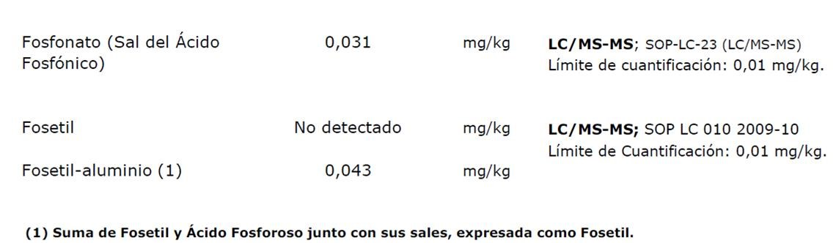

Example of a (Spanish) lab report indicating 0.031 mg/kg phosphonic acid, no detectable amount of fosetyl and the official amount of Fosetyl-Al.

Fosetyl may degrade in part or fully into phosphorous acid (and salts of phosphorous acid), but phosphorous acid will not transform into fosetyl.

This means that the presence or absence of fosetyl makes a big difference: presence of fosetyl should be linked to presence of fosetyl-Al where absence of fosetyl could be linked to fosetyl-Al as much as it can be linked to one or more other sources (see above).

**Summary of other studies regarding finding of phosphonic acid in plants and plant products**:

The result of absorption out of the plant’s environment taking into account the following:

1. Perennial crops

* e.g. fruit trees which accumulate the phosphonic acid which has been used on the plant as plant strengthener or on the soil in the past. Murcia CARM-imida study concluded that “phosphonates accumulate in woody tissues and are taken up from the soil, to be released in the plant even after many years after application. The BIOFOSF research project funded by Italian Ministry of Agriculture, referred to in the Federbio paper of November 2018, also came to the conclusion that phosphites, present in authorized for use by organic farmers were deposited in wood tissue for several years and were slowly released in the fruits up to five years after the take up. The CREA project Italy reaches the same conclusion stating that “phosphonic acid is translocated to young tree branches, leaves and fruits. Even if there is no use on the tree, productions containing phosphonic acid or salts thereof can be seen up to more than two years after the last application”. (historical pollution)

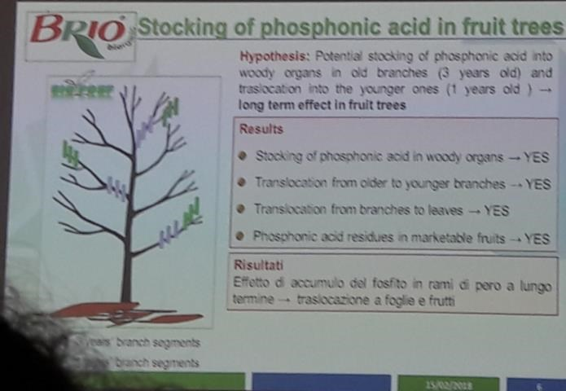

* vineyards (leaves) which have been treated with foliar fertilizer containing potassium phosphonate (authorized until 2013 in DE, thus also historical pollution) provided that use of such fertilizers was authorized in organic farming (which was not the case in FR)
* vineyard treated with copper solutions also containing phoshonic acid (not theoritically authorized but problematic for farmer if labelling does not comply with content)
* crops treated with foliar fertilizers made from conventional grapes must/marc or from sludge of conventional distillery and which contain phosphonic acid (example in France : 28ppm) provided that the use of such fertilizers is authorized.

1. Crops

* Grown in soil that has received soil amendments containing purins and manure which contain phosphonic acid salts (authorized)
* Which received algae or seaweed as organic foliar fertilizers (authorized). Yet, according to BNN this ‘natural source of phosphonates’ is considered rather suspicious
* Or soils which received substances that have been treated with chelating agents which contain phosphorous (not authorized but very difficult to detect in raw materials of soil amendments/fertilizers)
* Grown in soils which received chemical fertilizer/pesticides containing phosphate/phosphite (not authorized) examples

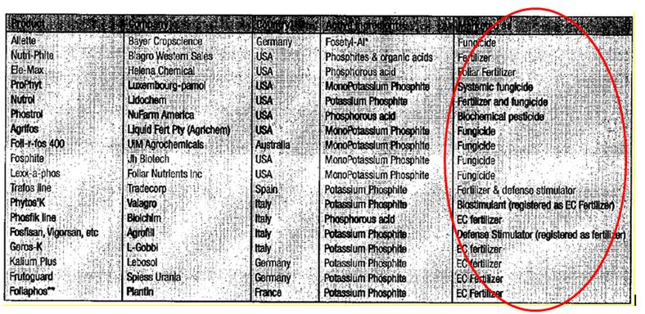

* Grown in soil which received allowed fertilizers and plant protection products containing phosphite/ fosetyl-al **above 2mg/kg.**

example : some commercial copper formulations

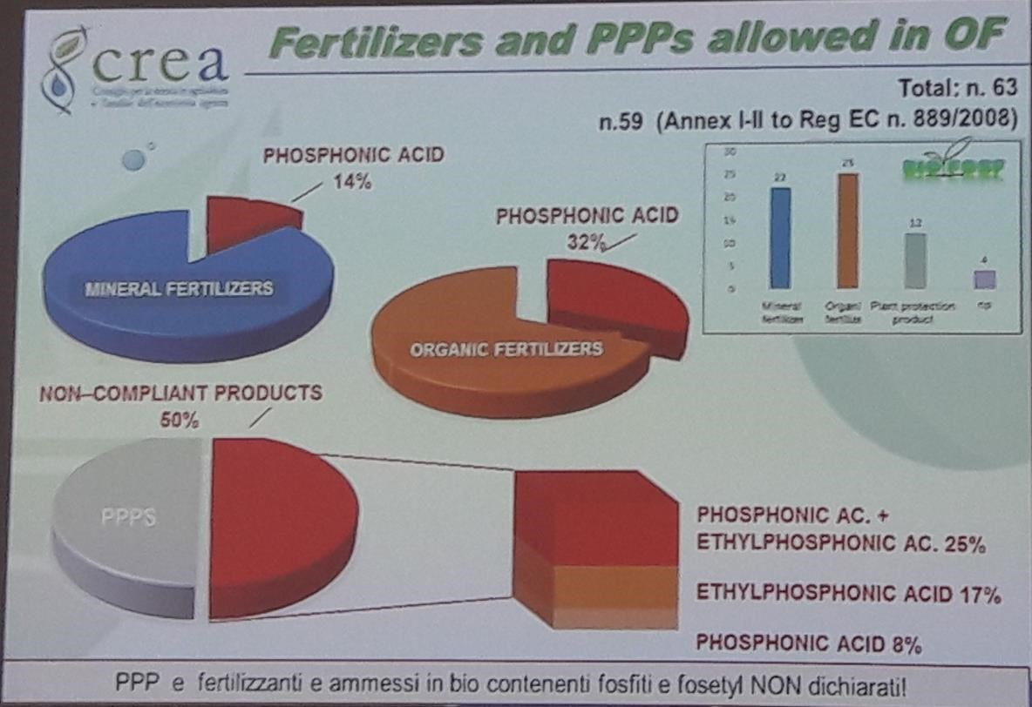

* v. . Grown in soil which has been treated with irrigation water which has received (water)treatments (not authorized)
* Crops have been treated with the fungicide fosetyl-aluminum which metabolized into fosetyl which degrades further into phosphonic acid salts (not authorized)

1. Suspicion that fosetyl is formed as an artefact during production or storage of wine.
2. Crops grown organically but having a conventional environment with use of fosetyl-al : fungicide with high volatility, easily transported by air (contamination source)
3. The result of plant growth under stressful conditions e.g. drought (supported by one source only)

# Organic products containing phosphonic acid (filtered by country)

Reporting by stakeholders of the organic sector shows that phosphonic acid is detected in different kinds of products and in different countries.

|  |  |  |
| --- | --- | --- |
| **Product** | **Number of samples analysed** | **% with phosphonic acid** |
| Asparagus | 21 | 38 |
| Grapefruit | 21 | 28.6 |
| Cucumber | 47 | 27.7 |
| Orange | 36 | 25 |
| Clementine | 22 | 18.2 |
| Table grapes | 57 | 18 |
| Potato | 24 | 16.7 |
| Pepper | 30 | 13 |
| Pear | 26 | 11.5 |
| Melon | 24 | 8.3 |

Analysis of phosphonic acid in samples of organic fruits and vegetables. 05-09-2016, BNN. Thomas Kimmel & Kirsten Arp

|  |  |
| --- | --- |
| Products | Number of cases |
| Berries | 8 |
| Cereals | 2 |
| Citrus | 12 |
| Vegetables | 20 |
| subtropical | 4 |

Data provided by CAAE (Spain), representing the number of cases between 2013 and 2018

|  |  |  |
| --- | --- | --- |
| **Country** | **Number of samples analysed** | **% with phosphonic acid** |
| Greece | 31 | 51.6 |
| Spain | 230 | 17.8 |
| Italy | 173 | 9.2 |
| France | 30 | 6.7 |
| Germany | 96 | 4.2 |
| The Netherlands | 20 |  |

Analysis of phosphonic acid in samples of organic fruits and vegetables. 05-09-2016, BNN. Thomas Kimmel & Kirsten Arp

EOCC members have been confronted with the following individual cases which required international investigation:

|  |  |  |  |  |
| --- | --- | --- | --- | --- |
| **Country of initial sampling** | **Product** | **Analytical results** | **Outcome of the investigation** | **Certification decision(s)** |
| Ivory Coast | pineapple (young fruits, before and after harvest) | Varying from 9.0 till 3.0 mg/kg | Potassium Sulfate (solid) was used as fertilizer and contained phosphonic acid and fosetyl. The presence of fosetyl is supposed to be due to contamination while producing the fertilizer but can also be intentionally applied to the fertilizer (by the farmer or seller of the fertilizer) |  |
| Costa Rica | unidentified | Not given | (conducted by Dole) investigation of rock phosphate by analysis showed presence of phosphonic acid |  |
| Costa Rica |  |  | Analysis of liquid fertilizer show absence of phosphonic acid or fosetyl. |  |
| South-Africa |  |  | Inspectors information about injection of fosetyl-Al in trunks. |  |

EOCC Task Force Residues, internal inquiry 2018.

**Non organic products containing phosphonic acid**

CVUA Stuttgart reports after the analysis of 4265 samples (from January 2014 to December 2015) that:

* 36% of all analysed samples contained residues of fosetyl and/or phosphonic acid above the LOQ
* Phosphonic acid is detected in concentrations approximately 40 times the concentration of fosetyl.
* Conventionally grown products contained phosphonic acid levels exsceeding the LOQ more frequently than products labelled as organic (39% vs 17% respectively)

# Food safety and MRL values

MRL values for Fosetyl-Al (sum of fosetyl, phosphonic acid and their salts, expressed as fosetyl) can be found in the MRL pesticide database (related to Reg 396/2005).

|  |  |
| --- | --- |
| **Product** | **MRL** |
| Asparagus | 2.0* |
| Grapefruit | 75.0 |
| Cucumber | 75.0 |
| Orange | 75.0 |
| Clementine | 75.0 (for mandarine) |
| Table grapes | 100.0 |
| Potato | 30.0 |
| Pepper | 130.0 |
| Pear | 75.0 |
| Melon | 75.0 |

<http://ec.europa.eu/food/plant/pesticides/eu-pesticidesdatabase/public/?event=pesticide.residue.CurrentMRL&language=EN>

* indicating the lowest analytical value for determination = the applicable MRL value.

MRL values for fosetyl-Al have been updated (increased) in 2015.

Before 2013, phosphonic acids were accepted as foliar fertilizer which could be authorized in organic farming (grape production). Since 2013, the double activity as foliar fertilizer and fungicide as no longer possible. Phosphonic acid has been included in the formulation of the fungicide fosetyl-Al and is no longer allowed as foliar fertilizer in organic farming.

# Imported products

Red fruits (strawberries, raspberries, blueberry) imported from Chile, Argentina, Canada (countries listed in Ann III of Reg 1235/2008 having in place an organic legislation equivalent to the EU Regulation 834/2007 for organic production and labelling). Suppliers from Chile already informed EU buyers that the plants have received authorized foliar fertilizer based on natural algae. “These algae may give a positive phosphonic acid result on residue testing”.

Red fruits from Serbia, Turkey, Ukraine (countries which do not have an organic legislation equivalent to the EU Regulation 834/2007) can be imported provided these products have been certified as compliant to it’s own standard by a control body recognized for issuing certificates of import for product category A (because always deep frozen) in each specific country.

Some red fruits in particular blueberries and cranberries are the result of wild collection/wild harvest. The particularity with that is that the areas where such products are collected do not receive any treatment at all. In such a context, the presence of phosphonic acid need to be investigated to exclude commingling with products not resulting from wild collection/wild harvest.

Red fruits are also interesting products for groups of operators (wild harvest or small scale production areas or a combination thereof). Such products, collected by groups of operators often consist of many and small size batches. Groups of operators are invited to develop their traceability system by installing batch numbers which allow to trace problematic batches back as far as possible. The smaller the problematic batch, the smaller the negative impact of blocking and downgrading.

# Preventive measures for operators (How to facilitate the investigation?)

**Farmers** need to have complete and up-to-date records which allow to identify that preventive measures are in place to reduce the risk of raw material contamination with phosphonates, and that only authorized substances have been used.

**Processors** need to be aware of the risks of false positive readings of residue analysis related to fosetyl-Al and anticipate the request for comments by knowing the production process of the organic products they process. Small size batches of raw material reduce the risk of blocking/downgrading raw materials and finished products. Samples of raw materials could be helpful to trace back where the problem comes from.

**Control bodies** need to inform their authorities about particular procedures related to the pesticide residue testing for Fosetyl-Al.

**Authorities** need to upgrade verification of compliance of labelling of inputs suitable for organic farming

**Phosphonic acid, organic food and babyfood.**

Contrary to the organic EU Regulation 834/2007, there is a system with MRL thresholds for babyfood (see Commission Directive 2006/141/EC). Any food placed on the market with reference to infants, should be free of pesticide residues exceeding 0.01 mg/kg. This level also applies to phosphonic acid.

# Member State specific policies

The Ministerial Note Prot. Uscita N.0041936 (IT) states that: “The presence of phosphorous acid in wine or other matrices, cannot and should not be directly attributed to the use of plant protection products based on Fosetyl-Al. From an analytical point of view, it is much more relevant to link the contamination with Fosetyl-Al to the simultaneous presence of phosphonic acid and fosetyl.” The Italian accreditation body (Accredia) has reported several cases of false positive reporting.

The Flemish (BE) decree of 2015 contains tresholds for pesticides in organic products. The protocol of the Flemish umbrella organization Bioforum Vlaanderen, included phosphonic acid as a substances for which an exception applies.

In July 2020 IFOAM Organic Europe made a report including this information on several EU countries by the Regulation Experts:

**IFOAM WG REGULATION STUDY ABOUT DIFFERENT WAYS OF DEALING WITH PHOSPHONIC ACID FINDINGS IN EU COUNTRIES. UPDATE 10 JULY 2020**

|  |  |  |  |  |  |  |  |  |  |  |  |  |  |  |
| --- | --- | --- | --- | --- | --- | --- | --- | --- | --- | --- | --- | --- | --- | --- |
|  | **Austria** | **Belgium** | **Denmark** | **France** | **Germany** | **Italy** | **Ireland** | **Netherlands** | **Norway** | **Poland** | **Spain** | **Sweden** | **Switzerland** | **United Kingdom** |
| ***1) if there is a national residue law in the EU Countries*** | No specific information provided | **Yes\*** | No specific information provided | **Yes\*** | **No** | **Yes\*** | **Yes\*** | No specific information provided | No specific information provided | **No** | **No** | **No** | **No** | No specific information provided |
| ***2) if there is a decertification limit for Phosphonic Acid and for Fosetyl in the EU Countries*** | No specific information provided | **No\*** | **No\***  **Case by case approach** | **No\*** | **No** | **Yes\*** | **Yes\*** | **No\*** | **No\***  **Case by case approach** | No specific information provided | **No\***  **Case by case approach** | No specific information provided | No specific information provided | **No\***  **Case by case approach** |
| ***3) if there is a limit above which the investigation is started in the EU Countries*** | **Always *case by case*** | **Always* *case by case*** | **Always *case by case*** | **LC\*** | **Always *case by case*** | **Any positive result\*** | **Always* *case by case*** | **Always* *case by case*** | **Always *case by case*** | **Always *case by case*** | **Any positive result\*** | **Always *case by case*** | **0,01 ppm** | **Always *case by case*** |

| **Country** | **National Approach Phosphonic acid - Fosetyl** |
| --- | --- |
| Austria | Last September our MIN informed us about a reply given by COM to MS during a COP meeting, after an inquiry by AT on how to assess residues of phosphonic acid (PA):AT approach to assess residues of PA was: Only if both PA and Fosetyl are found, a use is suspected.  If only PA is foundè no suspicion/no application/no follow up. This approach was not accepted by the COM. According to COM every finding of PA has to be reported via OFIS.This COM approach turned out totally impractical. therefore following up on a case by case basis. |
| Belgium | Instructions for CA/CBs from 2/07/2020:  - ALL cases are notified to the competent authority (no threshold is applied). The competent authority creates an OFIS notification.  - In ALL cases, the goods are blocked for at least 1 month. If within that time frame there is no additional indication or proof of irregularities (information received from the operator, involved CA/CBs or in OFIS) the goods may be released. If there is no reaction at all, best to send a reminder to the CB up-stream. If there are additional indications of irregularities it is to be decided case-by-case to prolong the ‘blocking period’ or to downgrade the products and if necessary to impose extra measures on the operator. Of course the goods may be released (even sooner than one month) if a conclusive investigation reveals no irregularities. |
| Denmark | Any presence leads to an investigation. The products are not decertified during investigation but they cannot enter the market during the investigation. |
| France | INAO has published on 03.07.2019 its ‘Common control provisions related to the analytical strategy to implement in the frame of control of operator of organic production’  These requirements replace the individual CA/CBs annual control plan and are to be applied from 01.01.2020.  This document describes the measures that each CB has to implement in order to determine if products or production technics non-authorized by Organic Agriculture rules are used by operators, or aiming to detect each potential contamination by products non-authorized in Organics. See more details in this link <https://extranet.inao.gouv.fr/fichier/INAO-DEC-CONT-AB-1.pdf>.    Besides, The French CA/CBs association (CEBIO) has approved an interpretation method in order to harmonise and manage particular cases that are either below 20 ppb or above 20 ppb.  = > For the Phosphonic acid case, all CEBIO members have approved that the level of 20 pbb is not to be applied for phosphonic case (given the datas of CA/CBs samples, experimentation, synthesis on feedbacks after investigation, litterature…)   * The level from which there is an investigation, a minima documentary, 0,2 mg/kg * The level from which the batch is blocked is currently applied by CA/CBs at 0,4 mg/kg   This, whatever the product analysed and at the condition that the laboratory fulfills the following requirements:   * Limit of quantification phosphonic acid below or equal to 0,1 mg/kg * Limite de quantification fosetyl natif below or equal to 0,01 mg/kg |
| Germany | We do not work here in Germany with national thresholds or orientation values. Contaminations with phosphonic acid are evaluated case by case, taking into account the various factors which might determine the origin of this contaminations. This is a fairly time consuming process, sand at least we are not very happy with it. Any level of contaminaton is investigated by CA/CBs |
| Italy | Current National Legislation that regulates findings of non authorized substances in organic products: DM 309/2011  In process to be published new Decree “*Modifica del Decreto ministeriale 13 gennaio 2011, n. 309 Contaminazione accidentali e tecnicamente inevitabili di prodotti fitosanitari in agricoltura* biologica” . It fixes the new limit of decertification for fosfonic/phosphourous acid at 0,05 ppm and etilphosfonic (Fosetyl Alumnium)  acid at 0,01 ppm for decertification. Till on next 31.12.2022 the limit shall 0,5 ppm for the annual crop and 1 ppm for the perennials.  For the new companies that will enter in the organic sector after the decree's publication will be possible to mantain the limit for the perennial crops (1 ppm) for not more 24 months only if the companies will monitor their cultivation about the presence of fosfonic acid in the wood of the trees  For grapes, wines, musts the decertification limit of etilfosfonic acid is 0,05 ppm and not 0,01 ppm as for all other products   * For processed foods these limits have to be calculated considering the concentration/dilution factors and the composition |
| Ireland | In Ireland we have to investigate any positive detections, with limit of detection increasingly advanced, this means even 0.3% of the MRL is investigated. However, above 10% of the MRL the product is automatically put on hold until outcome of the investigation. This can and has resulted in decertification of product. Another non-regulatory issue are the specifications of retailers (supermarkets) who are refusing products if any residue found, this is especially relevant to horticulture. Therefore, regardless of the level as a proportion of the MRL, product may be approved as organic by the CB, but not by retailer specifications. |
| Netherlands | The product will not automatically loose its organic status. Skal has to investigate each residue finding, investigation doesn’t always means a complete notification to 3rd country but also could be closed based on available information. Only when NL is notified by other EU country are we obligated to notify the CB in 3rd country by OFIS. |
| Norway | Norway does it the same way as Denmark: Any presence leads to an investigation. The products are not decertified during investigation but they cannot enter the market during the investigation. |
| Poland | No national rules and case by case approach.After the high pressure of the supervision auhority on decertification  in every case, in 2017 we have organised two lectures and one opinion of  a professor, and finally our supervision authority has understood that  that issue is not black or white. Other problem:  the big differencies of the test results of the samples  from the same lot in different laboratories. !!!! |
| Spain | There´s no national rules or proposal for harmonization at the moment although Competent Authorities are coordinated through the Ministry Coordination Board (MECOECO). Some Competent Authorities consider phosphonic acid as any other non authorized substance and every detection above LC should be investigated after blocking the market of the affected lots. For example, in the case of CCPAE (Control Authority in Cataluña), upon detection ≥ 0.01 ppm, appropriate investigations begin and depending on the batch is downgraded or not. If the detection is < 0.01 ppm, the operator is asked to investigate themselves and on the next inspection will be verified. Operator risk increases in both cases.  In May 2020 Andalusia Region has developed specific regulation <https://www.juntadeandalucia.es/export/drupaljda/ECO20_200521_Circular_1_2020_Fosfonatos_DGIICA-1.1-1_firmada.pdf> where catalogue of measures apply although in case of no irregularity found in the investigation, the lot could be released for this very first time as organic but the operator comes into a high risk control plan.. |
| Sweden | In Sweden there are no national rules for phosphonic acid. Instead there is a case by case rule that is applied. Depending on expertise advice it´s decided to stop product from entering market during investigation or not. |
| Switzerland | Our legal situation is same as in Germany (individual case by case decisions). FiBL has published an interesting study about residues of phosophonic acid in wine grapes after conversion to organic. In the study was one farmer with 0.36 mg phosphonic acid in grapes, 5 years after conversion, means 5 years after last legal use of fungicides with phosphonic acid. You can find the study (only german and french) in organic e-prints: <https://orgprints.org/36455/> in Switzerland CA/CBs allways have to investigate above 0.01. |
| United Kingdom | In the UK we investigate all residues regardless of the level, this can be particularly challenging when GMO's are being tested with a limit of detection of 0.005%. With regards to Phosphonic acid - Fosetyl specifically, as far as is possible we will follow the guidance in the factsheet produced by EOCC. A product will need to be held whilst the investigation takes place but would only lose its organic status following an investigation. |

# Similar issues

In the past, the presence of chloormequat in pear has also been considered as problematic. Investigations showed that pear tree accumulates chloormequat and gradually releases it which results in detectable amounts in pears while there has been no direct neither indirect application on the tree.

Phtalamide and Folpet. See other Fact Sheet EOCC TF Residues.

**Sources of information:**

* BNN
* Consiglio per la ricerca in agricoltura e l'analisi dell'economia agraria (CREA) (IT)
* CARM Imida study (ES)
* EOCC Task Force Residues (with special thanks to CAAE, TUV Nord Integra, SKAL, CCPB, CCPAE, Certisys, ECOCERT/IMO)
* Primoris (pesticide residue laboratory in BE)
* BIOFOSF research project funded by the Italian Ministry of Agriculture
* Federbio paper (November 2018)
* CREA project (Italy)

**Fact sheet reviewed by:**

* EOCC Board of directors